CLAIM/PREDICTION

Name: __________________________________________
CER: Claim, Evidence, Reasoning for Understanding Scientific Questions!
Date: _____________________
Hour: ______________
Grade: _____

Research Question:

Claim: Use your background knowledge to make your prediction.
I think______________________________________________________________ ____________________________________________________________________________________ _____________________________________________________________________________________

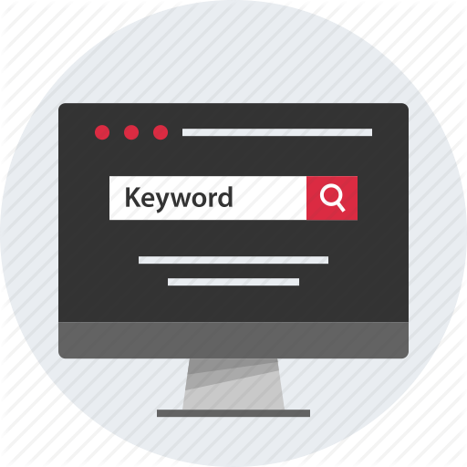
Helpful Resources: You may use the following list of reliable resources for your research if you choose. Do not forget you can use a keyword search on GOOGLE to help extract science content specific to your research.
_
_
_

EVIDENCE/RESEARCH
Evidence: Data/information used to support my claim. Review your work the checklist below.
- Two to three pieces of evidence
- Complete sentences using capitals and punctuation
- Quotations (borrowed work)
- Chart or diagram demonstrating knowledge of data

Facts/Evidence | Varied Resources  (Article/Video)

Chart or Diagram:

REASONING/PROVE IT!
Reasoning: PROVE how your data (evidence) supports or refutes your claim? Use complete sentences with capitals and punctuation.

My claim was _______________ because through my research I found __________________________________________________________________________________________________________________________________________________________________________________________________________________________________________________________
My first piece of evidence which ____________________ my thinking was found at the following website called: _____________________________________. It stated: “ ____________________________________________________________________________________________________________________________________________________________________________________________________________________________________________________________________________________________________________________________________________________
__________________________________________________________________________________________________________________________________________________________________________
My second piece of evidence which ____________________ my thinking was found at the following website called: _____________________________________. It stated: “
______________________________________________________________________________________________________________________________________________________________________________________________________________________________________________________________________________________________________________________________________________________________________________________________________________________________________________________________________________________________________________________________ _____________________________________________________________________________________ My third piece of evidence which ____________________ my thinking was found at the following website called: _____________________________________. It stated: “ ______________________________________________________________________________________________________________________________________________________________________________________________________________________________________________________________________________________________________________________________________________________________________________________________________________________________________________________________________________________________________________________________
To conclude I learned, _________________________________________________________________ __________________________________________________________________________________________________________________________________________________________________________
_______________________________________________________________________________________________________________________________________________________________________________________________________________________________________________________________________________________________________________________________________________________________________________________________________________________________________________________________________________________________________________________________________________________________________________________________________________________________________________________________________________________________________________________________________________________________________________________________________________________________________________________________________________________________________________________________________________________________________

Did I restate my first piece of evidence in my explanation? Yes/No
Did I restate my second piece of evidence in my explanation? Yes/No
Did I restate my third piece of evidence in my explanation? Yes/No
Did I apply my new knowledge to my writing? Yes/No

My Checklist
- Did I read the Big Question and circle my content words that I know?
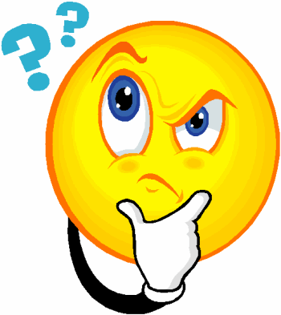
- Did I use the words I circled to do a Key Word Search on GOOGLE?
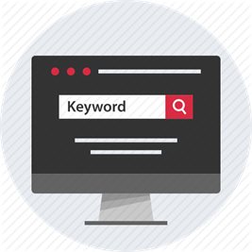
- Did I read the text and identify my science content words that I know?
- Did I analyze two diagrams or pictures to identify what I know?
- Did I write a summary (10 words or less) using my science content words that I know?
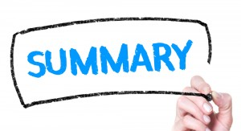
- Did I use capitals and periods in my statements?

