**CLAIM**

Name: __________________________________________

Date: _____________________

**My challenge**: I need to present my research about my dog breed and its characteristics during the dog show.

Hour: ______________

Grade: 6

**ASK QUESTION:**

How do inherited traits become adaptations?

**STATE CLAIM/HYPOTHESIS**: Use your prior knowledge to make a prediction based on facts you believe to be true.

*I think the inherited traits become adaptations over time because…___________________________*

*____________________________________________________________________________________*

**Identify Variables:**

-Independent variable (factor that I change on purpose): To be determined

-Dependent variable (factor that changes or is measured): To be determined

**List of Helpful Resources:** You may use the list of reliable resources for your research. Do not forget you can use a keyword search on GOOGLE to help extract science content specific to your research.



- McGraw Hill Textbook pages 214-230

- Brainpop Videos: Natural Selection, Genetics, Heredity and DNA

**EVIDENCE**

*🡪 NOTE: Evidence is facts… not opinions!*

1. *Must be able to be proven*
2. *Must always be true*

**Collect Data/Evidence** : Data/information used to support my claim. Review your work the checklist below.

* State name of Resource
* Complete sentences using capitals and punctuation
* Quotations (borrowed work)

|  |  |
| --- | --- |
| **Facts/Evidence**  **(picture OR written)** | **Resources (Article/Video)** |
| **Dog breed names:** | https://www.petfinder.com/dog-breeds/#Collection_Container |
| **What is a physical trait?** |  |
| **List 2 examples of what could cause a change in your dog breeds phenotype.** |  |
| **Dog physical traits (hair color and texture):** |  |
| **Dog traits (eye color and ear shape):** |  |
| **What is a behavioral trait?** |  |
| **Dog behavioral trait (exercise):** | http://clawbiespups.yolasite.com/resources/DogBreedCharacteristics.pdf |
| **List 3 or more behavioral traits of your dog breed:** | http://clawbiespups.yolasite.com/resources/DogBreedCharacteristics.pdf |
| **Dog behavioral trait (trainability):** | http://clawbiespups.yolasite.com/resources/DogBreedCharacteristics.pdf |
| **Dog behavioral trait (Before 1950):** | https://www.petfinder.com/dog-breeds/#Collection_Container |
| **Dog behavioral trait (1950s-present day):** | https://www.petfinder.com/dog-breeds/#Collection_Container |
| **What is a structural trait?** |  |
| **Dog structural traits:**   * + **body length in inches =**   + **leg length in inches =**   + **neck length in inches =**   + **body weight in pounds =** |  |
| **State what a mutation is AND what would cause this change in your dog breed?** |  |
| **State where your dog breed lives on Earth? (country AND continent)** | https://www.petfinder.com/dog-breeds/#Collection_Container |
| **Describe how your dog breed may need to adapt in order to survive where it lives.** |  |
| **State what an environmental extreme is AND possible extreme your dog breed maybe exposed to.** |  |
| **State if your dog has been selectively bred and explain your answer.** |  |

**#1 Chart or Diagram: Structure of DNA**

Analyze the chart or diagram. Then, write a summary describing the chart or diagram. Use the clue words: Chromosome, DNA, cell and nucleus in your response!

Summary: _____________________________________________________________________________________________________________________________________________________________________

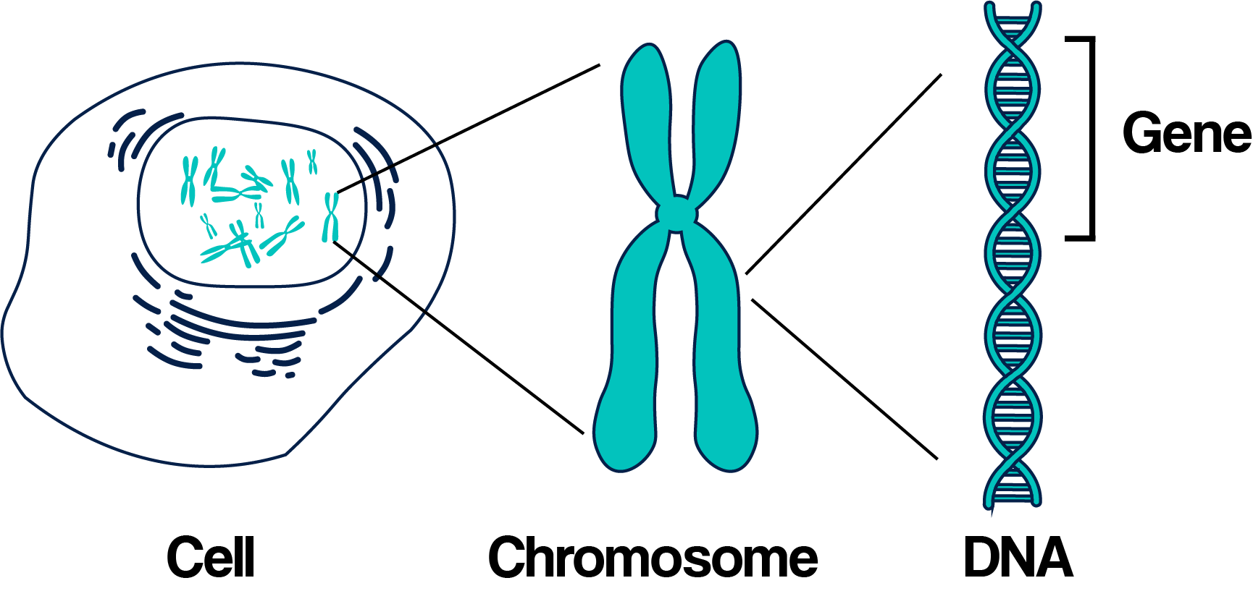

**#2 Chart or Diagram: Organisms and Natural Selection**

Analyze the chart or diagram. Then, write a description about the chart or diagram. Use the clue words: natural selection, adaption, gene and phenotype in your response!

Description: _________________________________________________________________________________________________________________________________________________________________________________________________________________________________________________________________________________

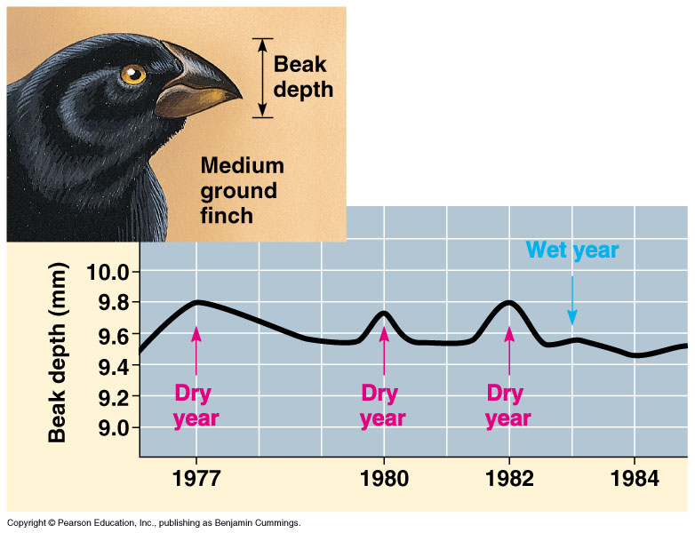

**#3 Sketch Diagram: Your Dog breed and ALL physical traits collected in research.**

**Test Claim**- To be determined🡪 SEE LAB RESULTS: DOG SHOW

**REASONING**

Explain how your dog’s breed and its inherited traits have helped it to adapt over time? (8+ sentences complete sentences)

_____________________________________________________________________________________________________________________________________________________________________________________________________________________________________________________________________________________________________________________________________________________________________________________________________________________________________________________________________________________________________________________________________________________________________________________________________________________________________________________________________________________________________________________________________________________________________________________________

_____________________________________________________________________________________________________________________________________________________________________________________________________________________________________________________________________________________________________________________________________________________________________________________________________________________________________________________________________________________________________________________________________________________________________________________________________________________________________________________________________________________________________________________________________________________________________________________________

________________________________________________________________________________________________________________________________________________________________________________________________________________________________________________________________________________________________________________________________________________________________________________________________________________________________________________________________________________________________________________________________________________________________________________________________________________________________________________________________________________________________________