Indicate the answer choice that best completes the statement or answers the question.

1. Which waves travel the deepest into the center of Earth?

2. Looking at the figure that shows world-wide earthquake distribution, the white lines represent plate boundaries. What
is a conclusion you can make about the relationship of earthquakes and plate boundaries?
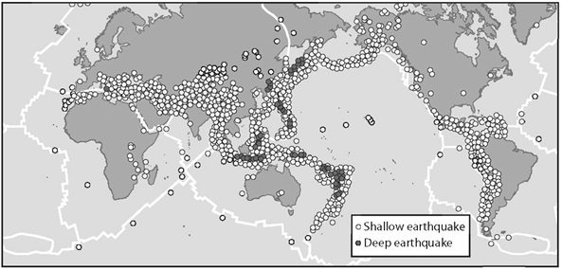

3. Define earthquake

4. What is the difference between the focus and the epicenter?

5. If you wanted to avoid earthquakes, which would be the best choice of location?
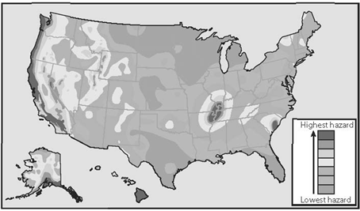

6. What are the three locations where volcanoes can form?

7. 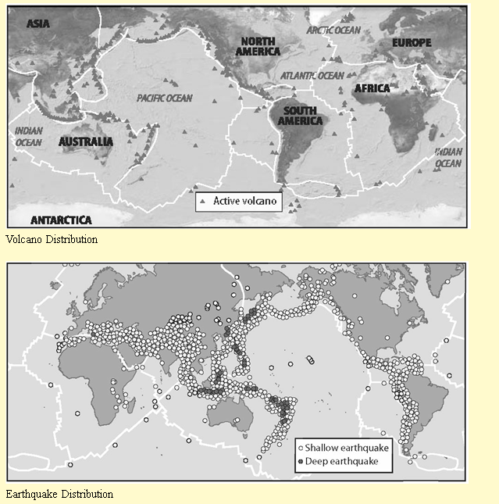

What do the two maps have in common?

8. 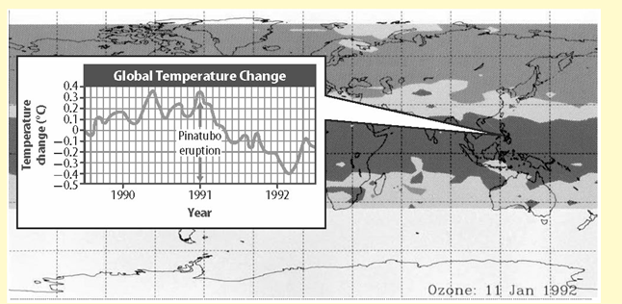
What happened to the global temperature after the Pinatubo eruption?
 | a. | It stayed the same
 | b. | It never changed
 | c. | It decreased
 | d. | It increased

9. A normal fault occurs where forces pull two blocks of rock apart. At which kind of plate boundary does this occur? Why?

10. What is the difference between the Modified Mercalli Scale and the Richter scale?

11. Define Volcano. Also, where do volcanoes typically occur? Can they occur on the ocean floor?

