1. Define Uniformitarianism

2. Compare/Contrast Absolute Age Dating and Relative Age Dating by making a Venn Diagram

3. What are index fossils?

4. 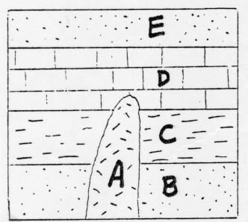List the Layers from Oldest to Youngest

5. Where do you typically find the oldest rock layer in a sequence?

6. With ____ dating, a rock's exact age can be determined, whereas with ____ dating, a rock's age is compared to the
ages of other rocks.
 | a. | absolute, relative | b. | relative, absolute
 | c. | true, absolute | d. | relative, approximate

7. Using the graph, determine the half-life of thorium-232.
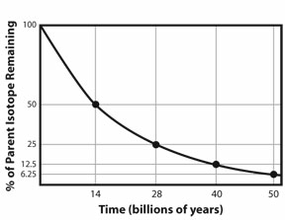

8. What characteristic of radioactive decay makes it useful for determining the absolute age of samples?

9. Is the principle of superposition used for absolute age dating or relative age dating?

Define each term.
principle of superposition

radiometric dating

Unconformities

half-life

index fossils

Uniformitarianism

radioactive decay

relative dating

