Atoms are the building block of all matter. Describe, the atom’s composition of molecules by explaining functions of each structure (proton, neutron and electron). | Contrast the following compositions of matter.  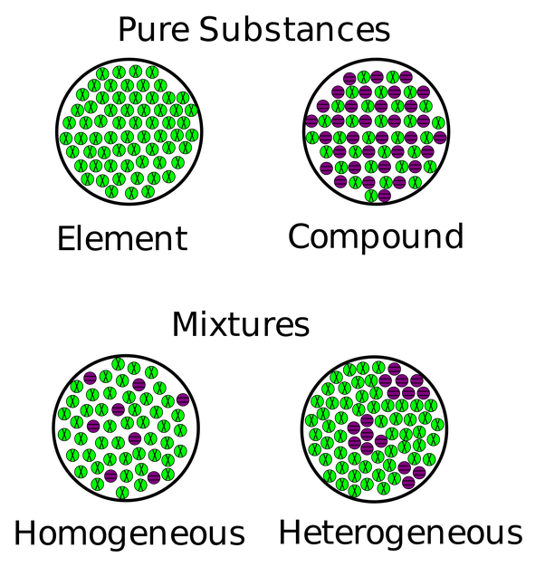 | 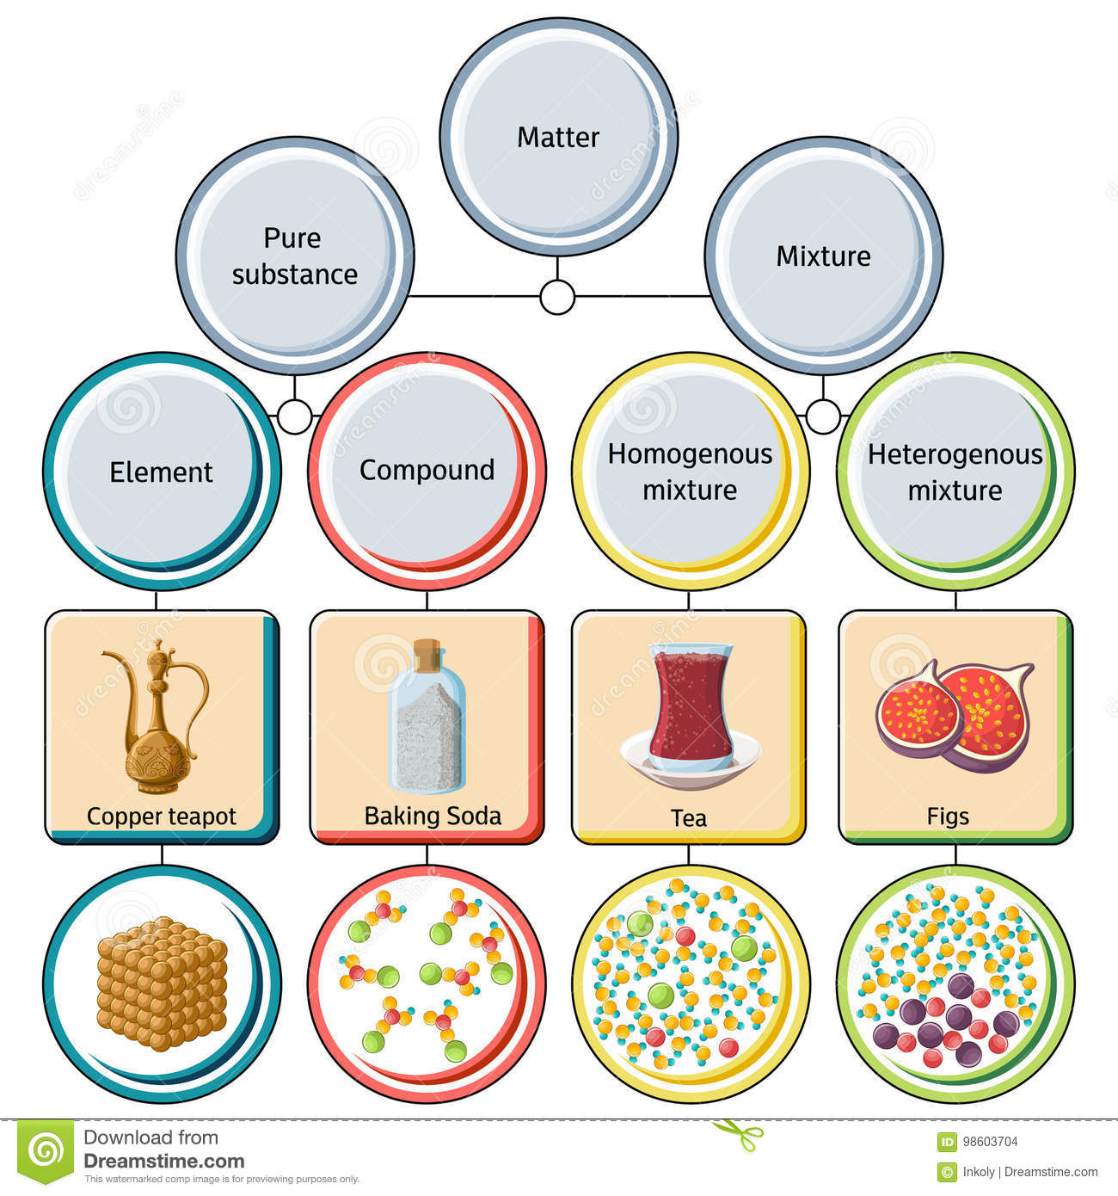  State an  example  of a pure  substance and  both types  of mixtures.  Cite evidence  using  the diagram at  right.
Draw and label the atomic structure of an atom IF given its atomic number.  Example: Lithium (an element found in many igneous rocks) has an atomic number of 3 on the periodic table of elements. Draw the atomic structure of lithium. Include the correct number of protons, neutrons and electrons in their electron cloud. | State and understand all vocabulary terms for Chapters 11 and 12  HINT: Refer to vocabulary handouts provided in class | Describe the composition of a compound. | Identify and state the charge of each of the following particles:  - Electron  - Neutron  - Proton  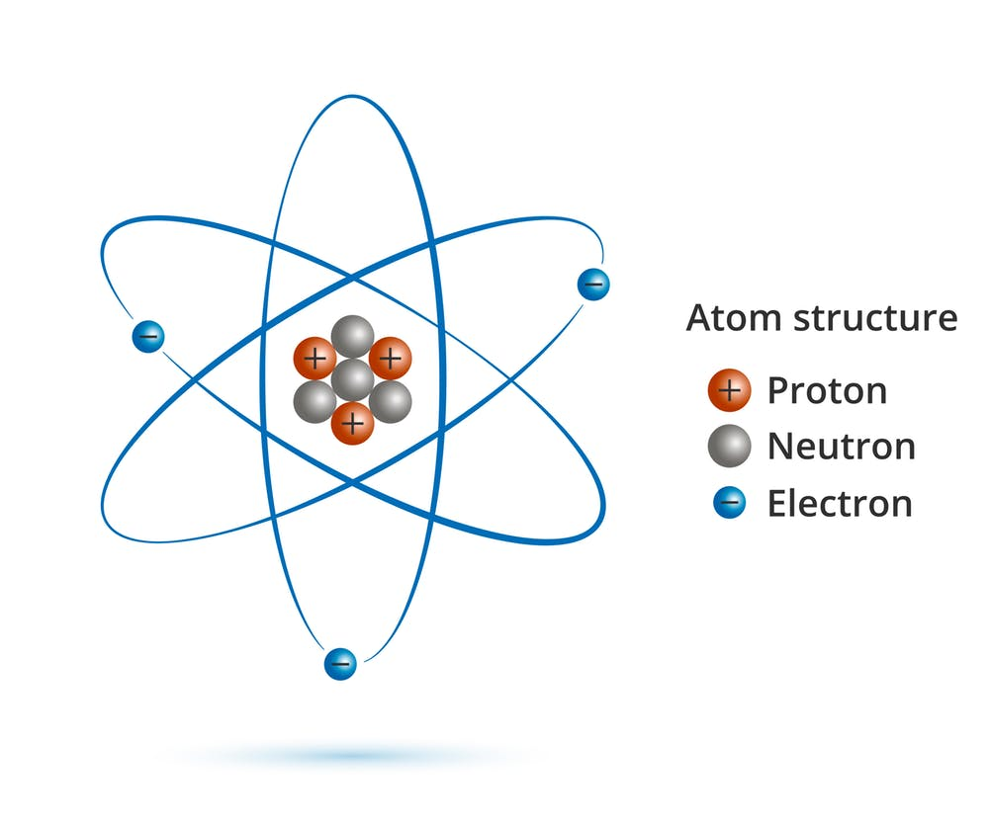
Describe the composition of an element. | Explain why an atom would be considered an ion and have a positive charge? A negative charge? | Contrast homogeneous and heterogeneous mixtures.  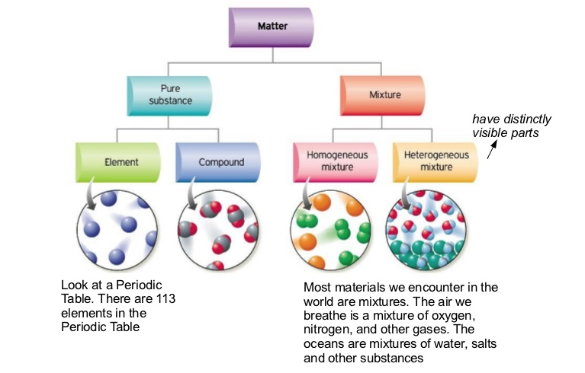 | State which substance keeps its own properties or features when mixed.
Contrast the states of matter AND describe the movement of particles within each.  State when a liquid becomes a gas? (Melting, freezing boiling stage?)  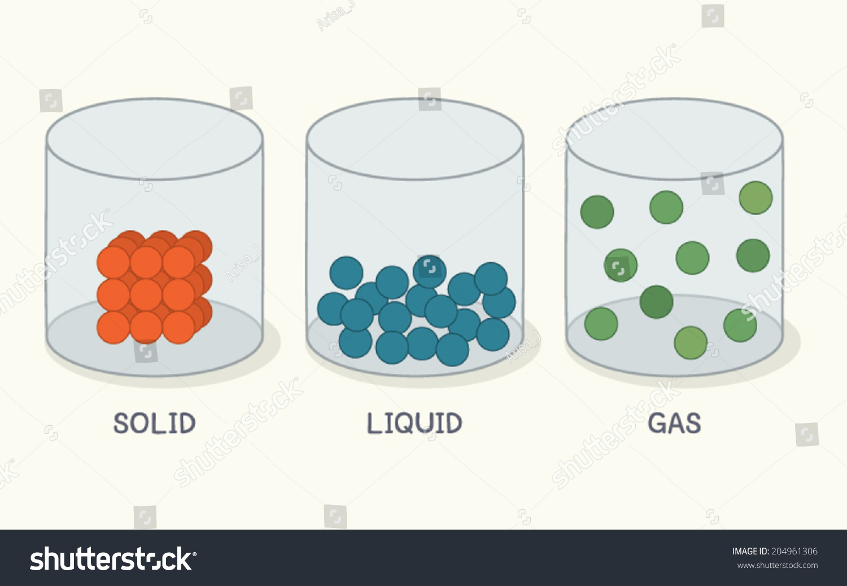 | State which of the following is NOT an example of a physical property and explain why.  - Shape  - Color  - Density  - Ability to react with another element | 1. Contrast physical change vs. physical properties AND chemical change vs. chemical properties.  2. State examples of each.  EXAMPLES:  - Rusting of iron nails?  - Orange juice being made?  - Plant making food out of other substances?  - Leaves changing color in fall?  - Describing the color of matter?  - Frying a hamburger? | State which of the following is NOT an example of a chemical property and explain why.  - Toxicity  - Ability to burn  - Ability to be crushed  - Ability to react with another element

