EARTH’S SYSTEMS CHILDREN’S BOOK: Chapter 3
- Page 1 = Title page and author
- Page 2 and 3 = First, write the question and answer in complete sentences. Then, draw, label and color a picture to model your thinking.

- What are the Earth’s systems?
- What is the composition & structure of the atmosphere?
- What is the composition & structure of the geosphere?

- Page 4 and 5 = Glue and color the diagram into booklet. Label your diagram with the cut out words.

- Page 6 and 7 = First, write the question and answer in complete sentences. Then, draw, label and color a picture to model your thinking.

- How does the water cycle show interactions of Earth systems?
- How does weather show interactions of Earth’s systems?
- How does the rock cycle show interactions of Earth systems?

- Page 8 = Conclusion. How can you describe Earth? Write three to six sentences. Be sure to highlight your clue words in your response!
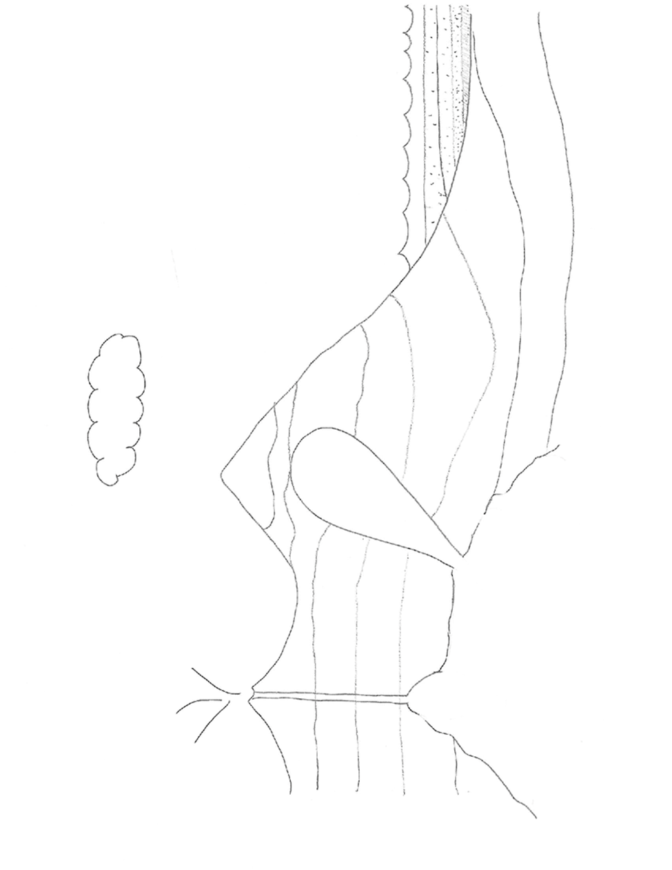

Cooling /crystallization
Igneous rock
Erosion
Deposition/sedimentation
Sedimentary rock
Metamorphism (heat and pressure)
Metamorphic rock
Evaporation
Precipitation
Transpiration
Respiration
Condensation

EARTH’S SYSTEMS CHILDREN’S BOOK: Chapter 3
- Page 1 = Title page and author
- Page 2 = Question, answer, picture, labels and color.

Q: What are the Earth’s systems?
A: The Earth’s four systems are _____________________.

- Page 3 = Question, answer, picture, labels and color.

Q: What is the structure of the atmosphere?
A: The five layers of the Earth’s atmosphere are _________.

- Page 4 = Question, answer, picture, labels and color.

Q: What is the structure of the geosphere?
A: The four layers of the Earth’s geosphere are ___________.

- Page 5 = Question, answer, picture, labels and color.

Q: Explain how the water cycle shows interactions of Earth’s four systems.
A: My first example is when the _______-sphere and the _______-sphere interact. When this occurs…________________.
A: My second example is when the ______-sphere and the ____-sphere interact. When this occurs…_______________________.

- Page 6 and 7 = Glue and color the diagram into booklet. Label your diagram with the cut out words.

- Page 8 = Conclusion. How can you describe Earth? Write at least three sentences. Be sure to highlight your clue words in your response!

