Answer each question to prepare for your test.

1. Why might we need to show the inner planets with a cut-out portion?
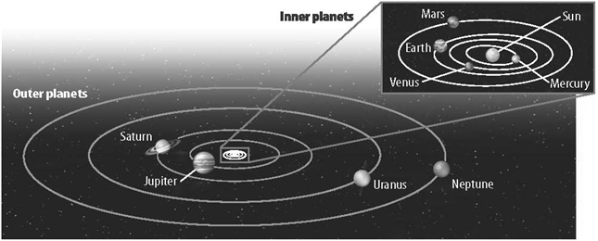
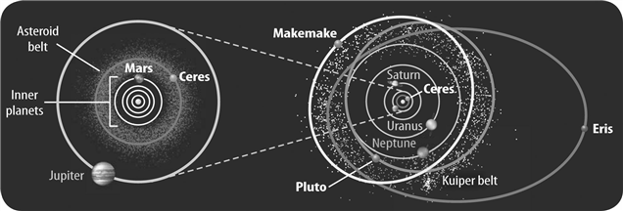

2. What is the basic shape of every planet’s orbit?

3. What causes planets and other space objects to revolve around the Sun rather than going off in a
straight line as indicated by the solid arrow in the picture below?
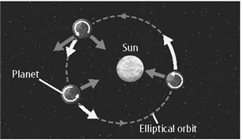

4. What are the inner planets? Outer planets?

5. Name some traits of the inner planets

6. What two gases make up most of the outer planets?

7. On Earth, hydrogen and helium are naturally found as gases. Why are they liquid on the outer planets?
 | a. | the temperature due to the distance from the Sun
 | b. | the pressure from the gravitational forces of the massive planets
 | c. | the distance from the Sun
 | d. | Both a and b

8. What are the traits of the outer planets?

Define the following terms (you need to know the difference between all of them)

Meteoroid-

Asteroid-

Meteorite-

Meteor-

11. _____ are patterns of stars in the sky.

12. Its _____ makes Sirius the brightest star in the night sky.
 | a. | apparent magnitude | b. | parallax
 | c. | color | d. | absolute magnitude

Define each form of measurement:
a. | apparent magnitude
b. | astronomical unit
c. | light-year
d. | Luminosity

Indicate the answer choice that best completes the statement or answers the question.

13. Which best describes the location of our solar system?
 | a. | in a galaxy called the Local Group, which is part of a cluster of galaxies called the Milky Way
 | b. | in a galaxy called the Milky Way, which is part of a cluster of galaxies called the Local Group
 | c. | in a galaxy called the Milky Way, which is not a part of a cluster of galaxies
 | d. | in a galaxy called the Milky Way, which is part of a cluster of galaxies called the Virgo Cluster

14. Describe each type of galaxy.
Spiral

Elliptical

Irregular

15. All of the following are true of the Milky Way EXCEPT that it _____.
 | a. | is a spiral galaxy | b. | has more than 800 billion stars
 | c. | is a member of the Local Group | d. | is 100,000 light-years across

16. Define Galaxy

